Terraform Final Task

- Create VPC
- Create Internet gateway
- Create Custom Route Table
- Create Subnet
- Associate subnet with Route Table
- Create Security Group to allow port 22.80,443
- Create a network interface with an ip in the subnet that was created in step 4
- Assign an elastic IP to the network interface created in step 7
- Create Ubuntu server and install/enable apache2

Task Title
Provision AWS VPC Infrastructure and Deploy Ubuntu EC2 with Apache using Terraform
Objective
To provision a custom AWS VPC network, enable internet access, deploy an Ubuntu EC2 instance using a custom network interface and Elastic IP, and automatically install and enable Apache web server using Terraform.
Prerequisites
- AWS account with required permissions (VPC, EC2, EIP)
- AWS CLI configured (aws configure)
- Terraform installed
- Basic understanding of AWS networking (VPC, subnet, IGW)
- Ubuntu AMI available in us-east-1
Step-by-Step Implementation:
Step 1: Configure AWS Provider
- Defined AWS provider with region us-east-1
- This allows Terraform to communicate with AWS APIs
Evidence:
Terraform initialization and apply succeeded without provider errors.
Step 2: Create a Custom VPC
- Created a VPC with CIDR block 10.0.0.0/22
- Tagged the VPC as vpctask
Evidence:
- VPC visible in AWS Console
- Status: Available
Step 3: Create and Attach Internet Gateway
- Created an Internet Gateway
- Attached it to the custom VPC
Purpose:
Enables outbound internet connectivity for resources inside the VPC.
Evidence:
- Internet Gateway attached to vpctask VPC in AWS Console
Step 4: Create a Public Subnet
- Created subnet with CIDR 10.0.1.0/28
- Availability Zone: us-east-1a
- Tagged as public subnet
Evidence:
- Subnet visible in AWS Console
- Associated with correct VPC and AZ
Step 5: Create a Custom Route Table
- Created a route table inside the VPC
- Tagged it as public route table
Purpose:
Controls traffic routing for the subnet.
Step 6: Add Internet Route
- Added route:
  - Destination: 0.0.0.0/0
  - Target: Internet Gateway
Purpose:
Allows instances in the subnet to access the internet.
Evidence:
- Route table shows 0.0.0.0/0 → igw as Active
Step 7: Associate Subnet with Route Table
- Associated the public subnet with the custom route table
Evidence:
- Subnet shows correct route table association in AWS Console
Step 8: Create Security Group
- Created security group allowing:
  - SSH (22)
  - HTTP (80)
  - HTTPS (443)
- Allowed inbound from 0.0.0.0/0
- Allowed all outbound traffic
Evidence:
- Security group created and attached to ENI
Step 9: Create Network Interface (ENI)
- Created a network interface in the public subnet
- Attached the security group to the ENI
Purpose:
Provides granular control over networking and Elastic IP attachment.
Evidence:
- ENI visible in AWS Console
- Correct subnet and security group attached
Step 10: Allocate and Associate Elastic IP
- Allocated Elastic IP
- Associated it with the custom ENI
Purpose:
Provides a static public IP for external access.
Evidence:
- Elastic IP visible in AWS Console
- Associated with ENI
- Output shows public IP
Step 11: Launch Ubuntu EC2 Instance
- Launched EC2 using Ubuntu AMI
- Instance type: t3.micro
- Availability Zone: us-east-1a
- Tagged as terraform-FinalTask
Important Detail:
- EC2 AZ matches subnet and ENI AZ to avoid attachment errors.
Evidence:
- Instance running in AWS Console
- Status: Running
Step 12: Attach ENI to EC2 Instance
- Attached custom ENI to EC2
- Used device_index = 1
  - Primary ENI (default) uses index 0
  - Custom ENI attached as secondary
Evidence:
- ENI attachment successful
- Terraform apply completed with no errors
Step 13: Install and Enable Apache using User Data
- Used user_data script to:
  - Update packages
  - Install Apache2
  - Start Apache service
  - Enable Apache on boot
Evidence:
- systemctl status apache2 shows active (running)
- Apache default page accessible via browser
Validation Steps
- Run:
- terraform apply
- Copy Elastic IP from Terraform output
- Open browser:
- http://<Elastic-IP>
- Verify Apache2 Default Page
- SSH into instance and run:
systemctl status apache2

Terraform code:
provider "aws" {
region = "us-east-1"
}
resource "aws_vpc" "vpc" {
cidr_block = "10.0.0.0/22"
tags = {
Name = "vpctask"
}
}
resource "aws_internet_gateway" "igw" {
vpc_id = aws_vpc.vpc.id
tags = {
Name = "Internet gateway"
}
}
resource "aws_subnet" "subnet" {
vpc_id = aws_vpc.vpc.id
cidr_block = "10.0.1.0/28"
availability_zone = "us-east-1a"
tags = {
Name = "public subnet"
}
}
resource "aws_route_table" "vpc" {
vpc_id = aws_vpc.vpc.id
tags = {
Name = "public route table"
subnet = "public subnet"
}
}
resource "aws_route_table_association" "a" {
subnet_id = aws_subnet.subnet.id
route_table_id = aws_route_table.vpc.id
}
resource "aws_route" "route" {
route_table_id = aws_route_table.vpc.id
destination_cidr_block = "0.0.0.0/0"
gateway_id = aws_internet_gateway.igw.id
}
resource "aws_security_group" "sg" {
vpc_id = aws_vpc.vpc.id
ingress {
from_port = 22
to_port = 22
protocol = "tcp"
cidr_blocks = ["0.0.0.0/0"]
}
ingress {
from_port = 80
to_port = 80
protocol = "tcp"
cidr_blocks = ["0.0.0.0/0"]
}
ingress {
from_port = 443
to_port = 443
protocol = "tcp"
cidr_blocks = ["0.0.0.0/0"]
}
egress {
from_port = 0
to_port = 0
protocol = "-1"
cidr_blocks = ["0.0.0.0/0"]
}
}
resource "aws_network_interface" "terraform_eni" {
subnet_id = aws_subnet.subnet.id
security_groups = [aws_security_group.sg.id]
tags = {
Name = "terraform-eni"
}
}
resource "aws_eip" "terraform_eip" {
domain = "vpc"
network_interface = aws_network_interface.terraform_eni.id
tags = {
Name = "terraform-eip"
}
}

resource "aws_instance" "terraform_instance" {
ami = "ami-0b6c6ebed2801a5cb"
instance_type = "t3.micro"
availability_zone = "us-east-1a"
user_data = <<-EOF
#!/bin/bash
apt update -y
apt install -y apache2
systemctl start apache2
systemctl enable apache2
EOF

tags = {
Name = "terraform-FinalTask"
}
}
resource "aws_network_interface_attachment" "eni_attach" {
instance_id = aws_instance.terraform_instance.id
network_interface_id = aws_network_interface.terraform_eni.id
device_index = 1
}

output "network_interface_id" {
value = aws_network_interface.terraform_eni.id
}
output "instance_public_ip" {
value = aws_eip.terraform_eip.public_ip
}
output "allocated_ipv4_address" {
value = aws_eip.terraform_eip.public_ip
}
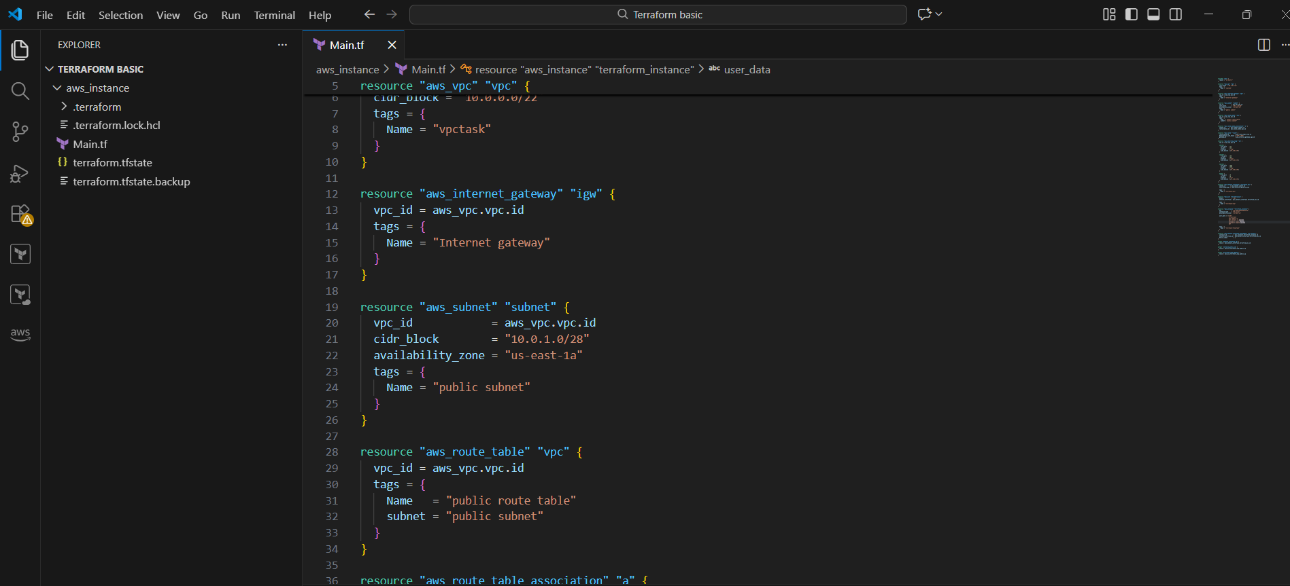
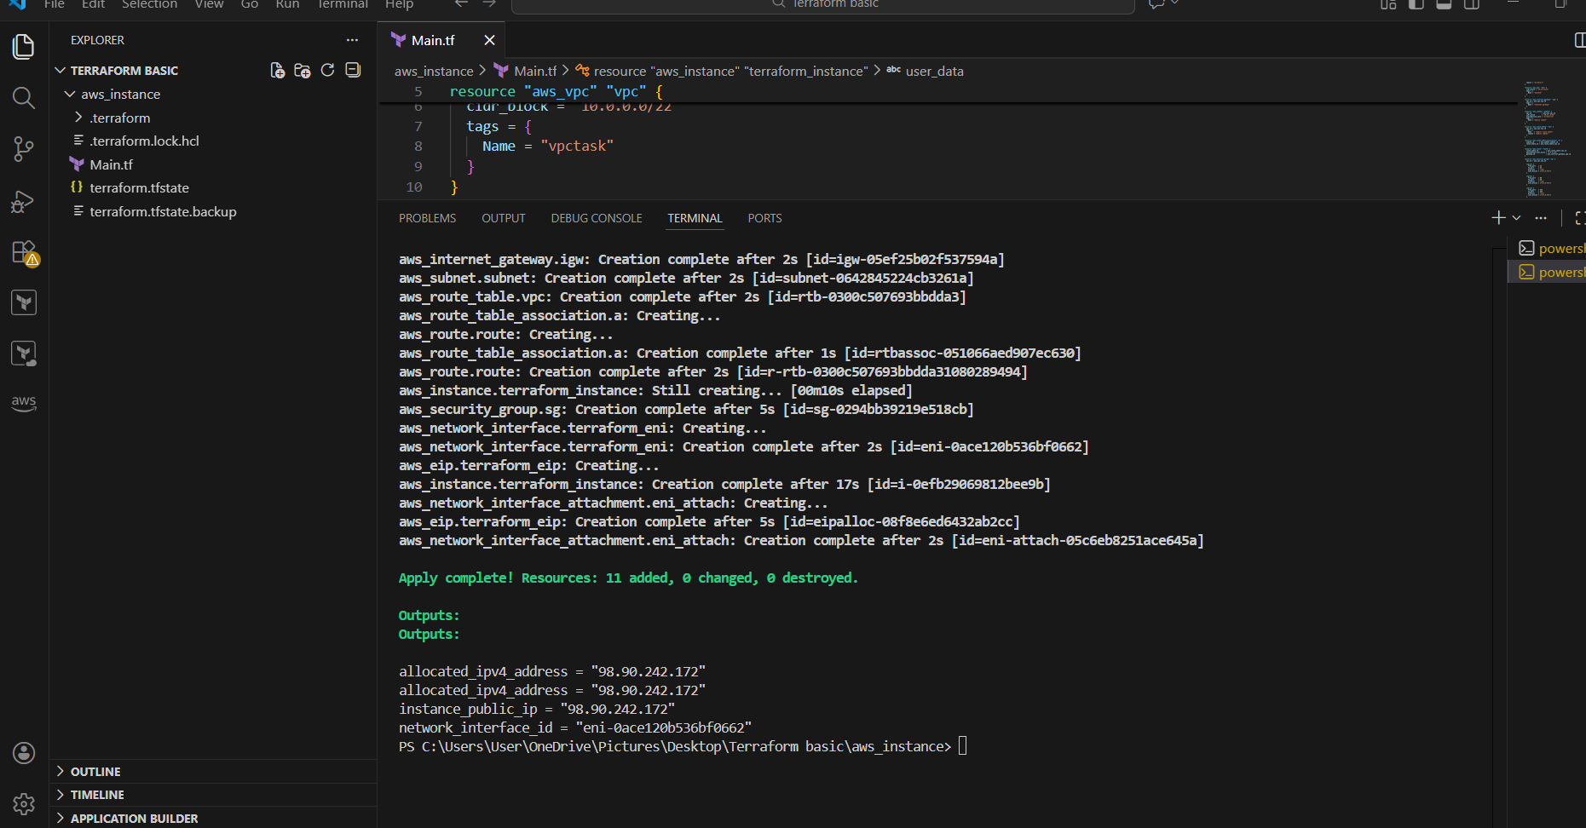
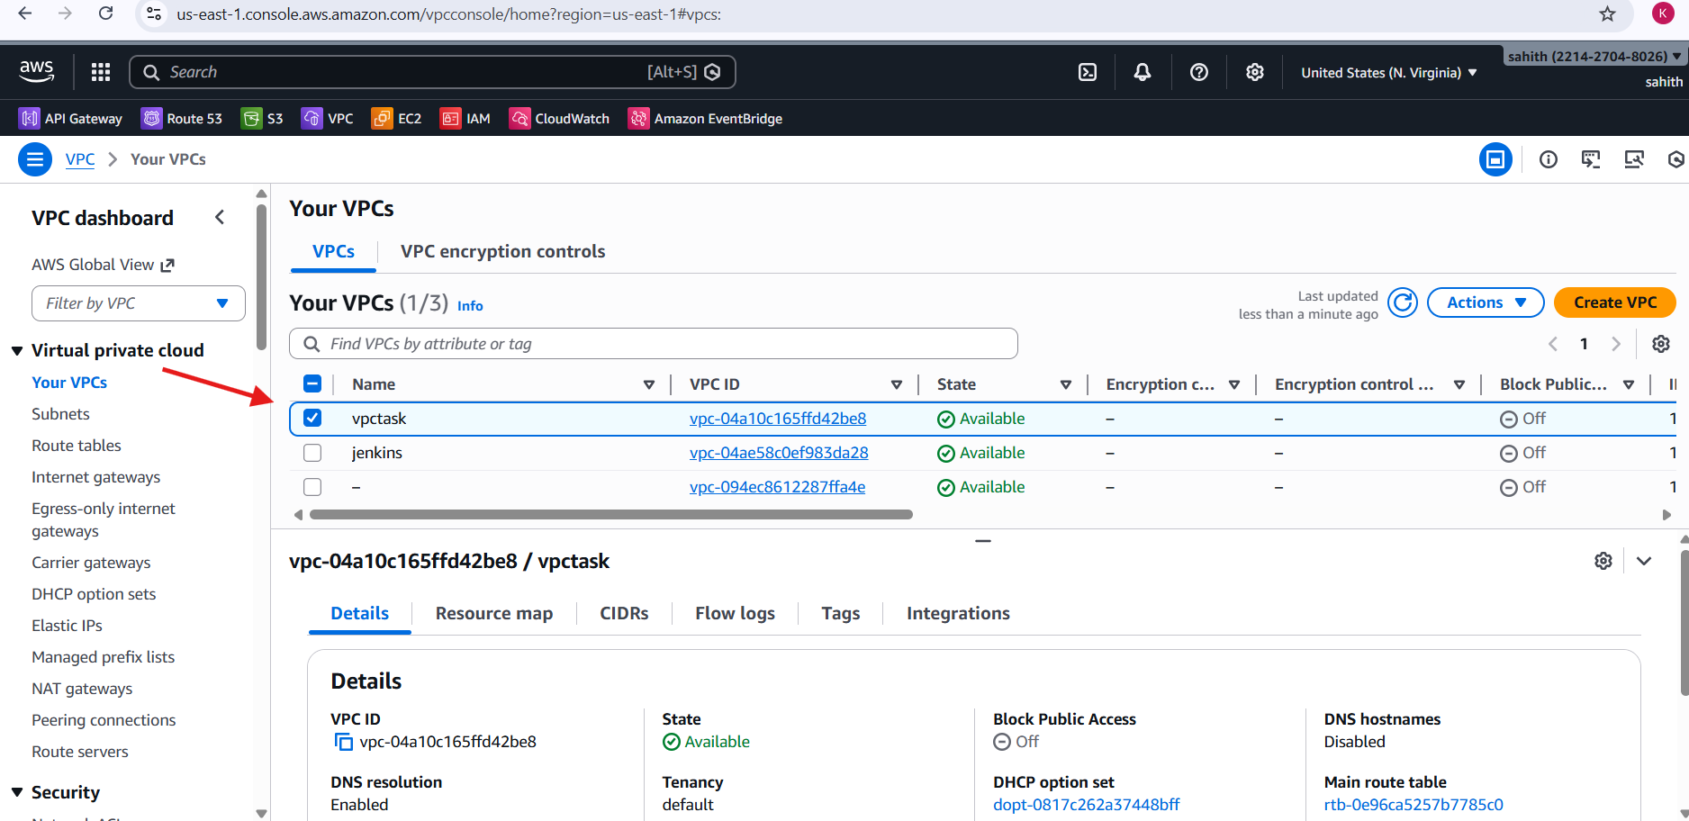
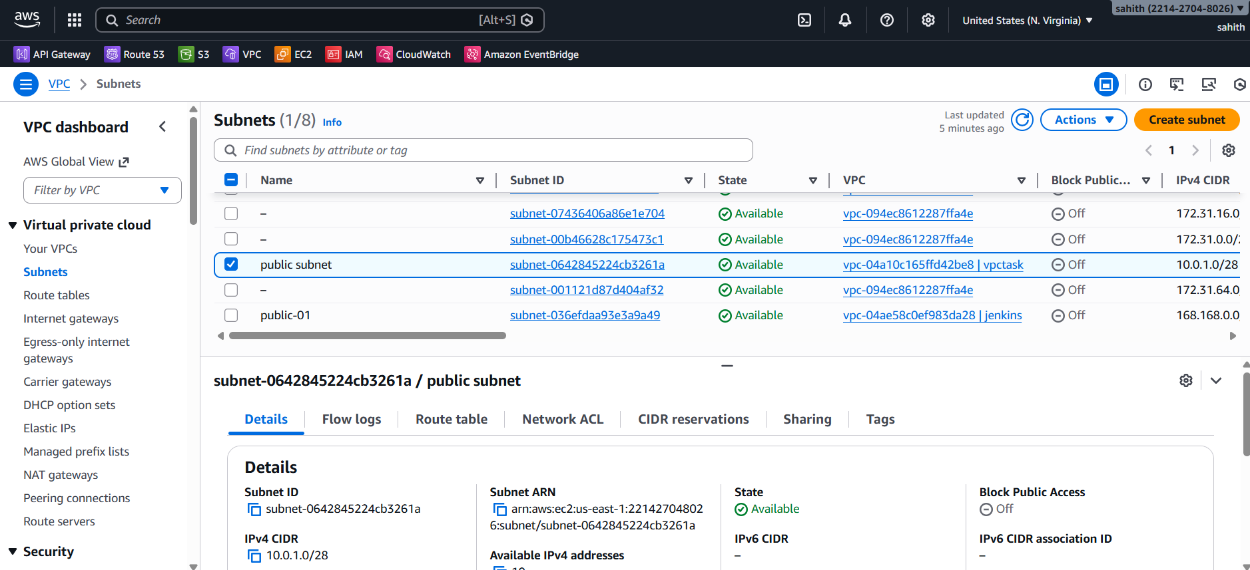
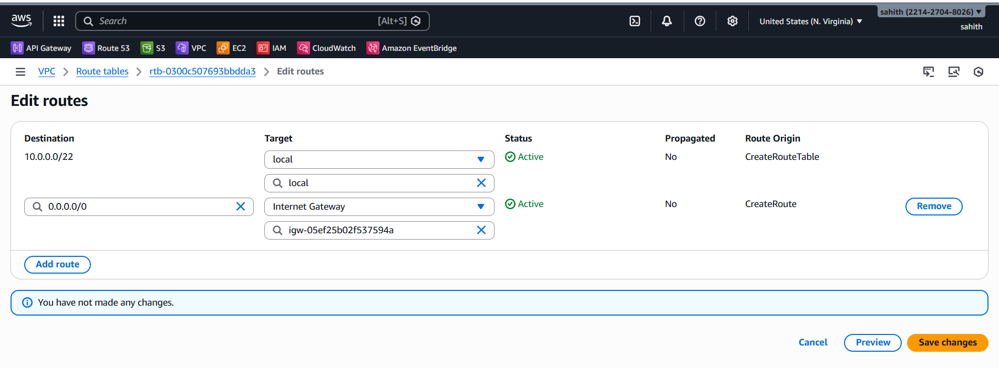
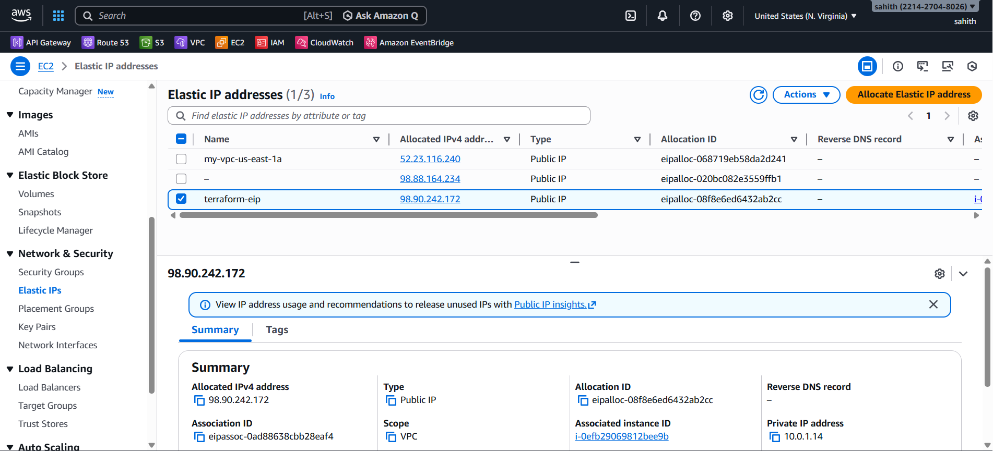
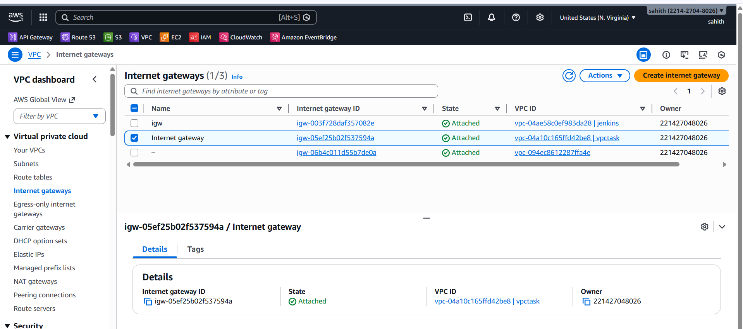
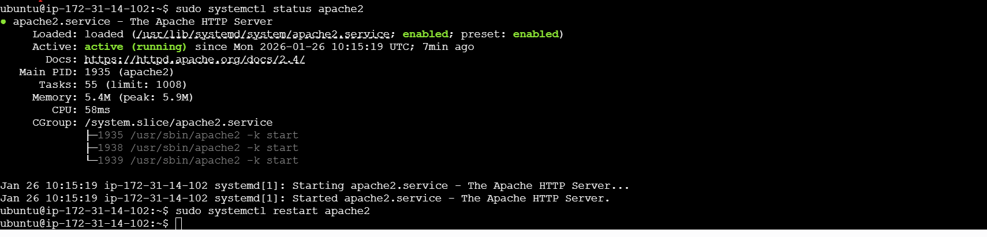
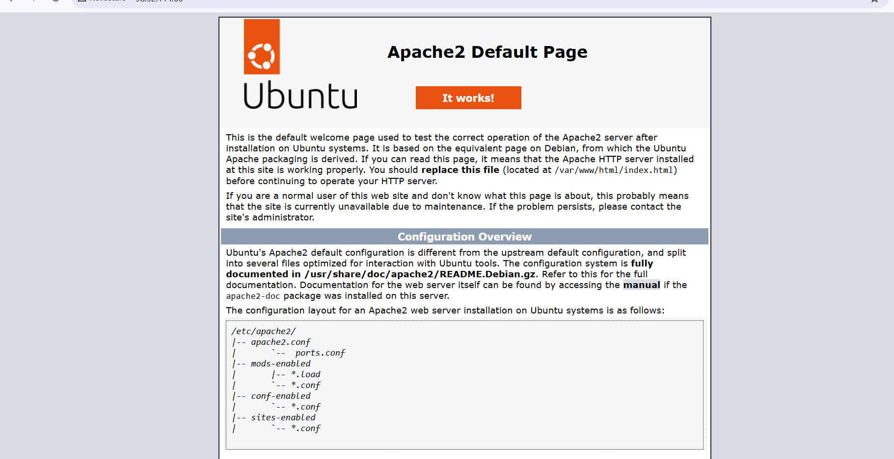
Issues faced:
Issue: Network interface attachment failed due to availability zone mismatch
Resolution: Set the EC2 availability zone to match the subnet and ENI
Issue: device_index conflict
Resolution: Used device_index = 1 for the custom ENI
Conclusion:
The Terraform configuration successfully provisioned a complete AWS network infrastructure and deployed an Ubuntu EC2 instance with Apache installed and running. The setup demonstrates proper use of VPC components, routing, security groups, Elastic IPs, and EC2 user data automation, making it suitable for real-world usage and interview demonstrations.

